September 2024

Healthy Food policy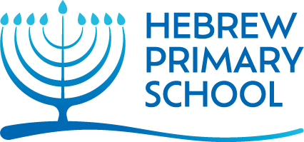

Introduction:
Hebrew Primary School is committed to encouraging and developing positive attitudes towards food and a healthy diet. We recognise the importance of offering children the opportunity to make informed choices about what, when, where and why they eat.
As a school we know that food is fundamental to the quality of a child’s life, not just in providing essential nutrition but in communicating and sharing positive values, attitudes and experiences with each other. We believe that adults (staff, parents and carers) should be good role models and should support the children in understanding how balanced nutrition contributes to a person’s health, happiness and general well-being.
The Torah tells us that ‘וְנִשְׁמַרְתֶּם מְאֹד לְנַפְשֹׁתֵיכֶם’ (Devarim 15:4) ‘We should guard our lives very carefully’. We must do everything in our power to avoid harm and keep our bodies as safe and healthy as possible. The Rambam in Hilchot Deot Chapter 4 writes that to live healthily is to follow in the ways of Hashem, as one cannot learn properly if one is ill. It is clear that a Torah outlook supports a healthy eating policy.
Aims and Objectives:
- To maintain the health of pupils, staff and the whole school community by helping to influence eating habits through increased knowledge and awareness of food issues including what constitutes a healthy diet.
- To ensure pupils are well nourished at school and that every pupil has access to safe and nutritious food and a safe, easily available water supply during the school day.
- To ensure that food provision in the school acknowledges the ethical and medical requirements of staff and pupils e.g. religious, vegetarian, medical and allergenic needs.
- To introduce and promote practices within the school to reinforce these aims.

The School Curriculum
Through our curricula, both Secular and Kodesh, we teach the children about the importance of living a healthy lifestyle.
The importance of balanced nutrition and healthy food choices is explicitly taught through the Science, D.T. and PHSE curriculum.
All pupils have the opportunity to learn about safe food preparation and to learn about where food has come from.
Pupils learn about the requirements for plant growth, the food chain and the components of a healthy diet through the Science curriculum.
Organisation
At Hebrew Primary School, we have agreed the following statements:
- Healthy eating is promoted through the curriculum and general culture of the school. However, it is recognised that there is a time and a place for ‘goodies’ and snacks and that moderation is part of the education that is promoted.
- Children may have plain carbohydrates for morning snacks, such as pretzels, crackers etc. and only fruit or vegetables for an afternoon snack.
- All food must have a Kosher seal of approval or approved on an acceptable Kosher List such as KLBD. The children may bring in cakes or biscuits on their birthdays to be shared with the class at a time which is convenient to the class teacher.
- We appreciate that families sending to our school have varying levels of stringency at home with respect to Kashrut. In order to ensure that all the children are able to be included in shared Semachot, for example, birthdays, we ask that when food is brought into the school to be shared (for example, birthday cakes), it should be in a sealed package (not homemade) with a Kosher seal. If the products to be shared are Chalavi, they should be Chalav Yisrael.
- Staff intending to give food to the children as rewards etc. must have these checked by the Senior Leadership Team prior to distributing them to the class. Rewards should not be sweets or chocolates or food items.
- All children are encouraged to bring in a water bottle so they can have access to water throughout the day.
- Sweets, sour sticks, nuts and nut products and chewing gum are not permitted in school at any time.
- Chocolate, biscuits, crisps, fizzy drinks and cakes are not permitted as everyday snacks in school or as part of lunch boxes except on Rosh Chodesh.
- Crackers (plain, rice or corn cakes, plain crackers and breadsticks) pretzels (plain), Humzingers, School Bars and YoYo Bars, raisins as well as fresh fruit and vegetables may be eaten after lunch or during afternoon break.
- Pupils’ lunch boxes should offer balanced nutrition. Across week parents are encouraged to offer a variety of healthy foods. Sandwiches could include matzo, bread, rolls, pita with fillings such as cheese, tuna, cream cheese, egg mayonnaise, smoked salmon. Other lunch options could include fish balls (cut into 1/4, pasta, fresh salad, yoghurt, soya products, fresh fruit and vegetables, always cut into small bitesize chunks. and a carton/bottle of water or fruit juice with no added sugar. Children must bring at least a small piece of bread or matza in order to join in with Hamotzi and birchat hamazon. Children who are Gluten Free are exempt but can bring in gluten free bread.
- We do recognise that there is no such thing as “bad food”, so we teach the children to enjoy treats in moderation. Rosh Chodesh and for a Siyum, children are permitted to enjoy treats. These “treats” should still be in moderation with careful consideration for those with allergies. They may include crisps, bissli, wafers, popcorn and cakes.
- Birthdays in class is also a time where food contributes to a sense of celebration and sharing. On these occasions only cakes or cookies are permitted and permission needs to be obtained from the class teacher as to a suitable time.
- We are aware of the possibility of food allergies with certain children, particularly nut allergies which is why Hebrew Primary School is a nut-free school. Parents or carers of children who are on special diets for medical reasons, or who have allergies, will be asked to provide as much information as possible about which foods are suitable and foods which must be avoided. This information will be displayed discretely in each classroom.
- Pupils are taught not to share packed lunches and parents are reminded about the need to avoid sending in packed lunches containing nuts.
The role of the head Teacher:
It is the responsibility of the Head Teacher to ensure that staff and parents are informed about the healthy eating policy, and that the policy is implemented effectively.
It is the Head Teacher’s role to ensure that staff are given sufficient training, so that they can teach effectively.
The Head Teacher liaises with external agencies regarding the healthy eating education programme and ensures that all adults who work with children on these issues are aware of the school policy and work within this framework.
The Head Teacher monitors teaching and learning about healthy eating.
The role of Parents:
The school is aware that the primary role model in children’s healthy eating education lies with parents. We wish to build a positive and supportive relationship with the parents of children at our school through mutual understanding, trust and co-operation. In promoting this objective we will:
• Inform parents about the school healthy eating education policy and practice.
• Inform parents about healthy eating so that the parents can support the messages being given to children at school.
Parents will:
- Ensure that children are given a healthy school lunch in line with school policy
- Ensure that children are given healthy snacks during the day.
The role of Governors:
The governing body is responsible for monitoring the healthy eating policy.
The governors support the Head teacher in following guidelines from external agencies.

Monitoring and review
The effective implementation of this policy will be monitored by the Head teacher and the governing body.

Hebrew Primary School
Healthy Eating Policy
We can eat:
Morning break:
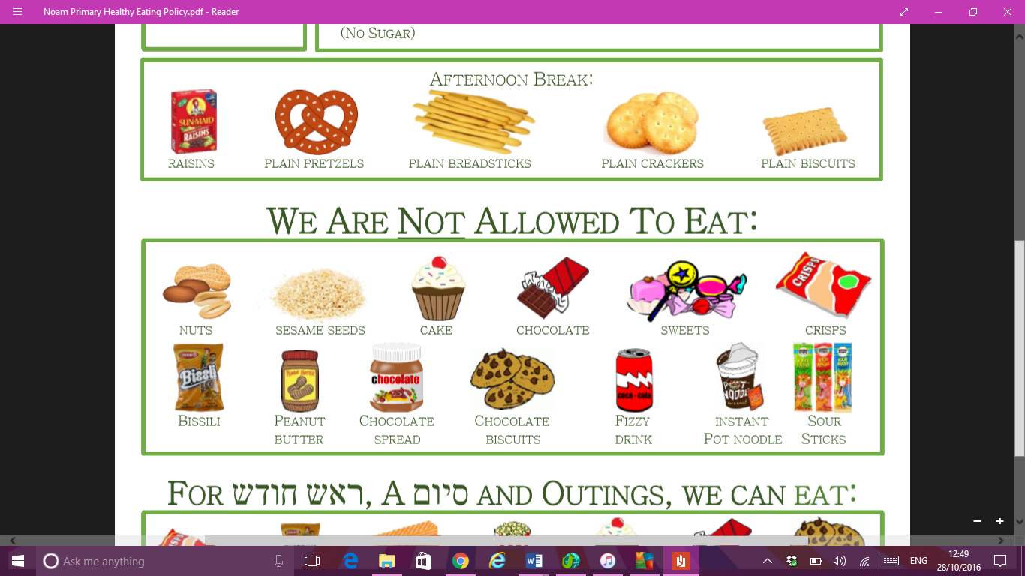
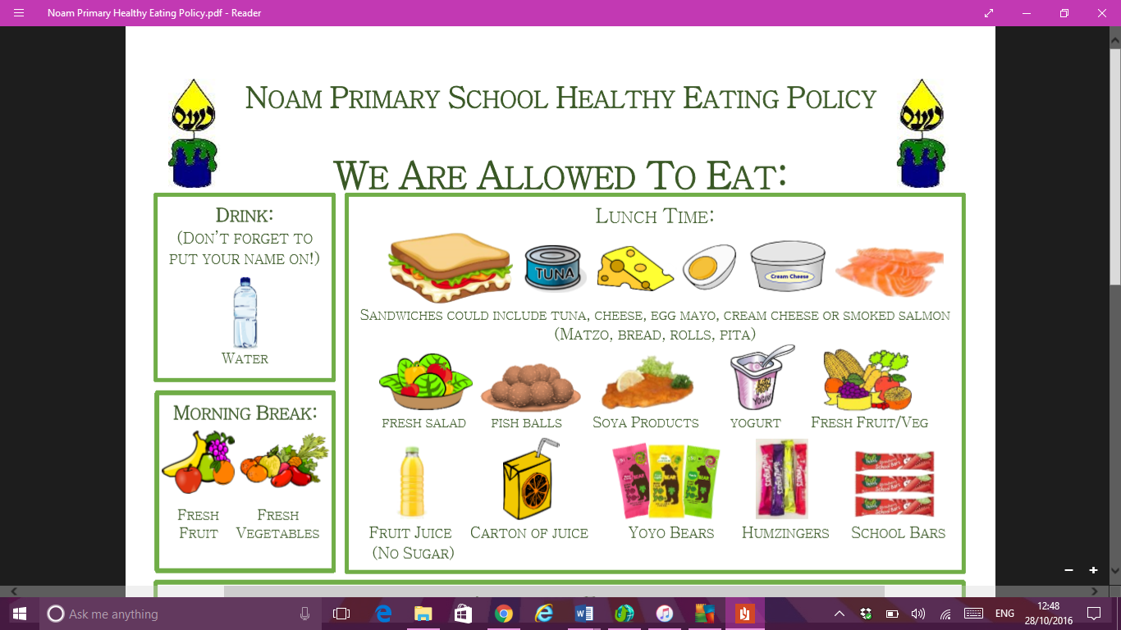
Meaty products, thermos flasks with warm food, pasta etc are all fine for lunch. No Pot Noodles.
Afternoon break:
We cannot eat:
For Rosh Chodesh, a Siyum and outings we can eat:
